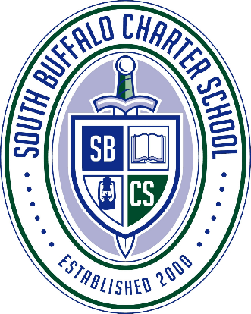

OPEN HOUSE

OPEN ENROLLMENT

When: Tuesday, February 25, 2025, from 5:30 to 7:00pm
Where: 154 South Ogden Street
Why: Perspective 2025/2026 school year students. This is an opportunity to enroll brand new students to our great school for the next school year. Take a student guided tour, ask questions, and learn all about South Buffalo Charter School.
Who should come? Any family that is looking to enroll their child(ren) in grades K-8 for the 2025/2026 school year.

SBCS is a tuition free public school. We offer transportation for all students that attend. Special Education and English as a Second Language programs are available. All students receive a chrome book for school use, and our student teacher ratio is 11:1, giving your child a great opportunity to succeed. Come visit our 20+ acre campus, our new building, and speak with students, administration and teachers.

To enroll online follow this link by April 1, 2025: https://enrollment.powerschool.com/family/ActionForms/Public/200004225
