Investigating the pH Scale

1. Navigate to the PhET “pH scale” Simulation.
- You can google “PhET pH scale”, go to the first link, then click on the play button in the center of the picture
- OR you can follow this link: https://phet.colorado.edu/sims/html/ph-scale/latest/ph-scale_en.html
2. Click on the “Macro” box.
3. There is a pH scale on the left hand side of the screen. Label the pH scale below as acidic and basic.
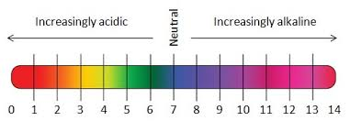
_______________
_______________

Substance | pH | acid/base
Drain cleaner
Hand soap
Blood
Spit
Milk
Chicken Soup
Coffee
Orange Juice
Soda Pop
Vomit
Battery Acid
4. Investigate the pH of each of the following substances.
- Drag the pH sensor into the solution to see the pH reading.
- Record the pH of the substance and whether the substance falls into the acid or base end of the pH scale.

5. Now add these substances to the pH scale above.
6. Using the information from the chart and simulation answer the following questions.
  - What pH values correspond to acids?

  - What pH values correspond to bases?

7. Now test five substances and see how the addition of water affects the pH. Record your data below. Be sure to do at least 2 acids and 2 bases.
Substance | Volume (Liters) |  | pH |  | Which direction did pH move?
 | Initial | Final | Initial | Final

8. Based on your data how does addition of water affect the pH of the solutions?

