Tenochtitlan, the biggest Aztec city, was built on an island in the middle of Lake Texcoco. The Aztecs didn't have any farmland, so they devised a way to create their own farmland, called chinampas.
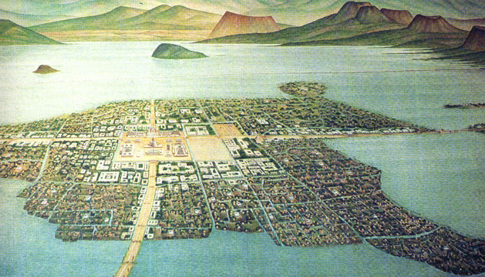
The Aztecs made giant reed mats and placed them on top of the water. They made a fence around the mat and placed mud, fertilizer, and rotten vegetables on it. Then trees were planted on all sides of the chinampa. The trees grew very quickly and their roots held the soil to keep it from flowing away. The Aztecs planted corn, tomatoes, potatoes, peppers, and squash. The plants' roots would grow to the bottom of the lake so they would have an endless supply of water. The chinampas were man made islands created by piling up mud from the bottom of the lake. The size of the chinampas didn't matter; what mattered was if two canoes could go between the chinampas. The mud that the Aztecs used to build the chinampas had lot of fertilizer for growing crops. The Aztecs didn't use any plows or any vehicles at all; they only needed and used a simple wooden digging stick and a wooden hoe for growing and harvesting crops.

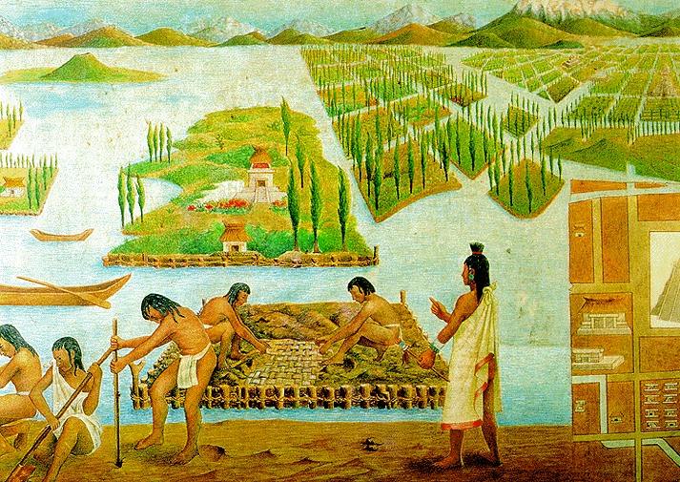
Aztec fishermen made fishing nets near the chinampas to catch fresh water turtles, ducks and fish also.

